## **Objectives**

**Explain branching and merging**

Branching in Git is used to create a separate line of development from the main branch (usually “master” or “main”). This allows developers to work on new features or bug fixes without affecting the main codebase. Once the work is complete, the branch is merged back into the main branch. Merging brings all the changes together, allowing the project to stay up to date with the latest developments.

**Explain about creating a branch request in GitLab**

A branch request in GitLab involves creating a new branch from the repository, usually based on the “main” branch. This branch is used to make specific changes or work on a feature. It can be created from the GitLab UI by going to Repository>Branches and clicking “New Branch”. This process helps in organizing work and keeping the main branch clean.

**Explain about creating a merge request in GitLab**

A merge request (MR) in GitLab is a way to propose changes from one branch into another. After pushing changes to a branch, a developer can create a merge request to have their code reviewed before it is added to the main project. It helps in team collaboration, code reviews, and version control. Merge requests can be created under the “Merge Requests” section in GitLab.

**Setting up Git environment with P4Merge tool for Windows**

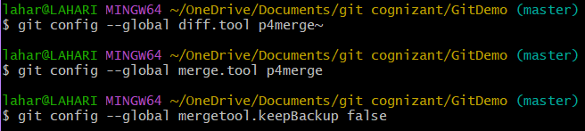

**Branching:**







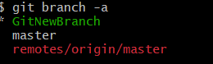



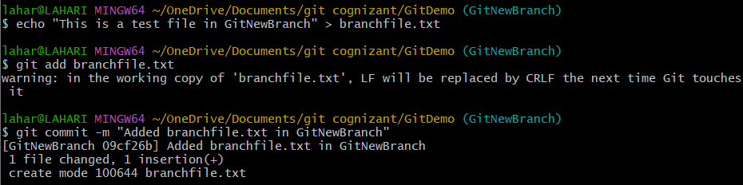

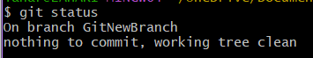

**Merging:**



